Clinic Date: May 22, 2021
Clinic Location: Douglas County Fairgrounds, Castle Rock, CO

Clinician: Simone Windeler, USDF ‘L’ Graduate, Western Dressage ‘R’ Judge

These sessions are suited for all levels, come join us for one or all learning opportunities at this beautiful indoor arena! This clinic will be a day filled with tips and examples on how you can make every ride productive and successful for both you and your horse.

Session 1 will focus on achieving an effective warm up. Assess your horse, consider how your body feels and work on a mutually productive program. This not only results in a better ride, but it can prevent injuries and increase your horse’s longevity.

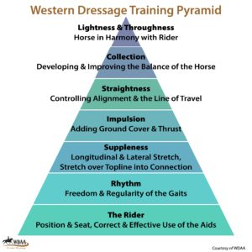
Session 2 focuses on using the Western Dressage Pyramid and WDAA Guidelines for Western Dressage Training Progression. Simone Windeler will help you put together a roadmap to create a training program that suits you and your horse. You’ll learn how to assess progress and stay on track with or without going to shows and getting scores from the judge.

Included is a luncheon presentation on “How to mentally prepare for a perfect ride - every time” and available to all auditors.

After lunch we offer an opportunity to
Ride-A-Test. You will be judged and scored as if you were at a show. This is a great opportunity for first time competitors or those riders who would like to bump themselves up a level for the experience but without the stress. Those who wish to participate have an opportunity to sit with the judge during this time to learn more about the perspective from C (where the judge sits) and learn about the scoring scale.

Clinic Schedule

Session 1: 9 am to 10:30 am
Effective Warm–up based on your horse’s level
$100 WDACO members, $125 nonmembers

Session 2: 10:45 am to 12:15 pm
Using the Western Dressage Pyramid to achieve a better ride
$100 WDACO members, $125 nonmembers

Lunch Session 12:30pm to 1:30 pm
Preparing mentally for a perfect ride
Bring your lunch;
Clinic participants, paid auditors or WDACO members
join this conversation at no additional charge

Ride-A-Test 2- 5pm +/-
You pick the test that you would like to ride! Then receive feedback from the judge (Simone Windeler) and have an opportunity to re-ride certain test movements.
15 min private sessions $35 WDACO members, $45 nonmembers

Sit with the Judge 2-5pm +/-
This is for those who would like to learn more about the judge’s perspective at C and how the Scoring Scale is applied. It will be after lunch during the Ride-a-test. $20

Additional Pricing:
Lunch Theory Session is included with all mounted sessions and free for WDACO members; $25 for nonmember

Auditor: $25 full day, WDACO Members no charge. Includes morning riding sessions plus lunch theory session

Sit with the Judge $20 per person includes Ride-a-Test with the judge at C

Stalls: $15 each / day

Trailer hook-up: $35 each / day

WDACO membership is only $25/year. Join this great WDAA Affiliate at the time of clinic registration and save $! Go to WDACO.org to register. Deadline is May 6, 2021

For more information contact:
Silja Knoll 970 402 5104 or siljaknoll@yahoo.com or
Pamela Stenmark at 970 376 1124 or pamelas.wdaco@gmail.com

To register please go to WDACO.org
Registration Deadline: May 6, 2021

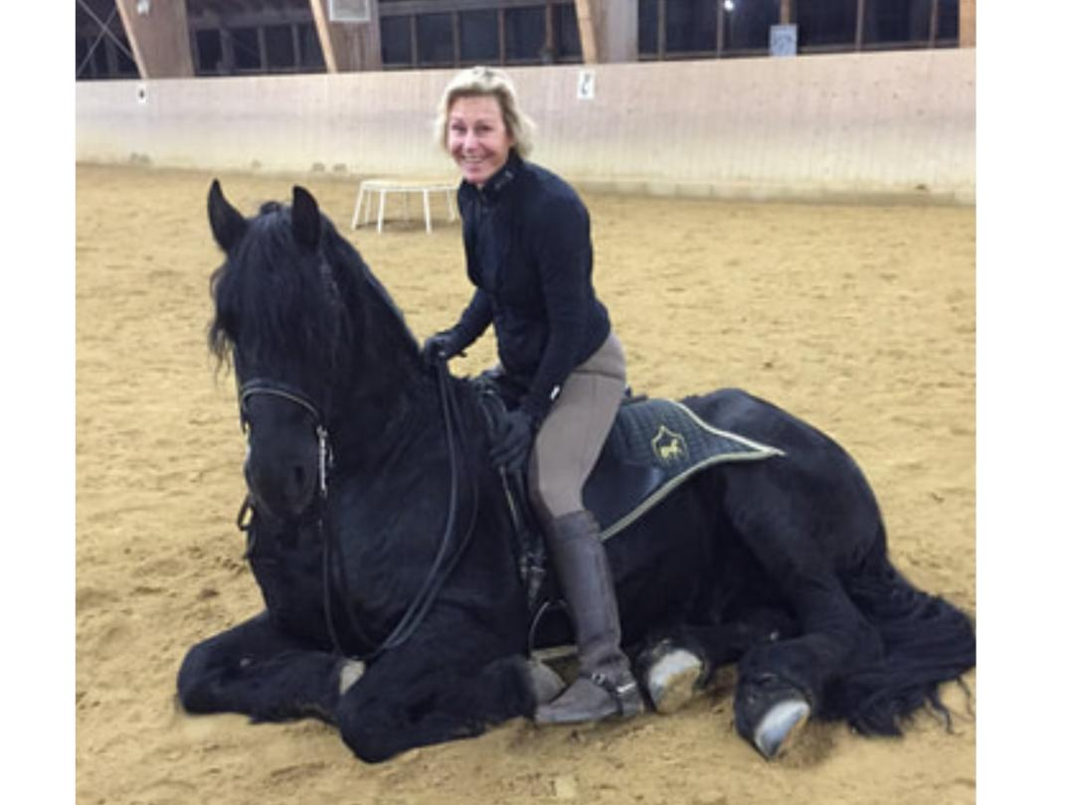
Simone Windeler

Western Dressage Association of Colorado Mission Statement
The mission of the Western Dressage Association® of Colorado is to build an equine community that combines the Western traditions of horse and rider with Classical Dressage. In doing this it will provide an educational and competitive environment which is accessible to all Colorado riders and horses. Our mission will be guided by that of the Western Dressage Association® of America which states:
We honor the horse.
We value the partnership between horse and rider.
We celebrate the legacy of the American West.
“It’s about the journey.” – Larry Mahan, American cowboy

