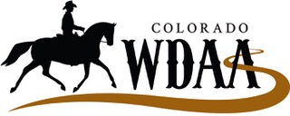

Understanding Western Dressage and how it can Aid in Overall Balance and Training

Clinic Date: April 17, 2021
Clinician: Julie Haugen, USDF ‘r’ judge, USEF WD ‘R’ Judge
Location: Rafter MB Arena, 210 Sybille Creek, Wheatland, WY

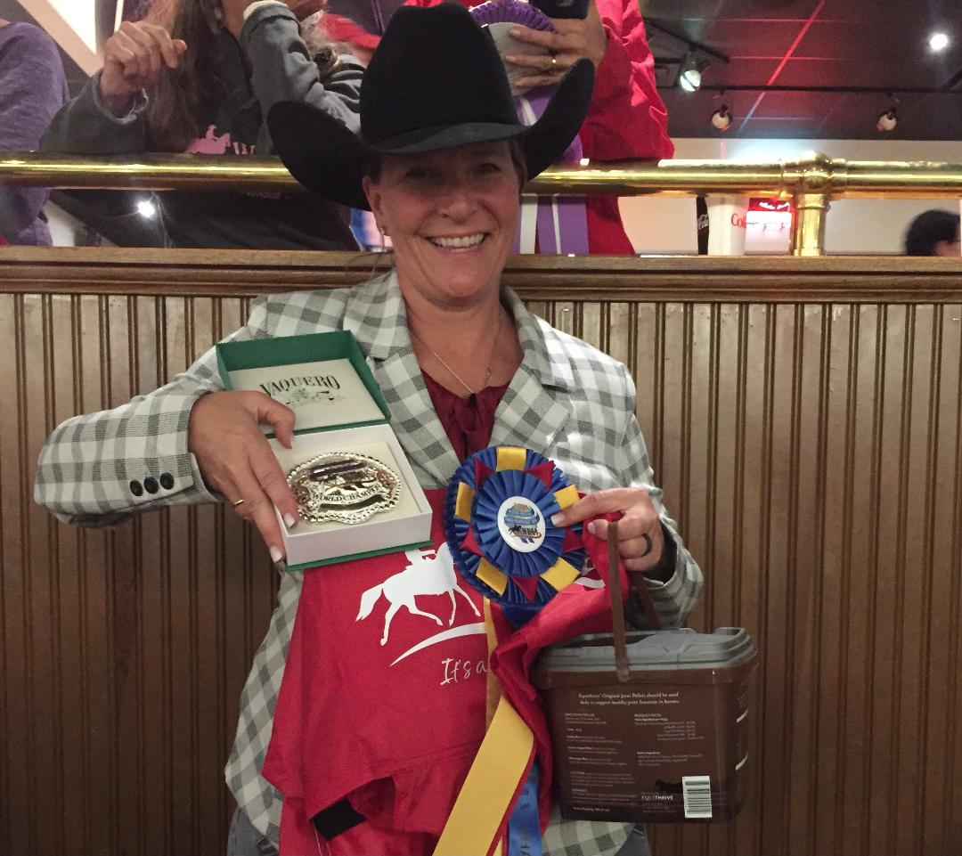

Julie Haugen has over 30 years of experience training multiple breeds in various disciplines and instructing all levels of riders. The principles of dressage are at the core of her passion which she uses to help both horse and rider to become the best team they can be. She has won or facilitated the win of over 45 National and World titles in the Morgan Breed and Western Dressage arenas. Her biggest pride is in seeing her clients succeed in the arena, whether it be at home or the show pen. Becoming a USEF Judge in both traditional Dressage and Western Dressage has aided in her teaching and helped to clarify her passion for these divisions.
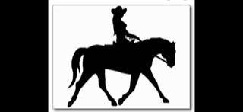

This fun and educational clinic is suitable for riders of all abilities!!
- Riders will be in groups of 3-4 in a 2 hour session.
- Will include an introduction to Western Dressage principles for horses and riders and how to integrate it into your everyday training.
- Anyone who would like will have the opportunity to ride a test and receive Julie’s feedback. This is a great opportunity to learn from each other!
- Everyone is encouraged to audit other sessions throughout the day at no extra charge.
$85 per rider/session

For information contact: Mariah Jerviss: 805 798 2256 at Rafter MB Arena or
Silja Knoll 970 402 5104 (Clinic Coordinator Western Dressage Association of Colorado)

To Register go to WDACO.org Deadline to register is April 9st, 2021

Western Dressage Association of Colorado Mission Statement
The mission of the Western Dressage Association® of Colorado is to build an equine community that combines the Western traditions of horse and rider with Classical Dressage. In doing this it will provide an educational and competitive environment which is accessible to all Colorado riders and horses. Our mission will be guided by that of the Western Dressage Association® of America which states:
We honor the horse.
We value the partnership between horse and rider.
We celebrate the legacy of the American West.
“It’s about the journey.” – Larry Mahan, American cowboy

