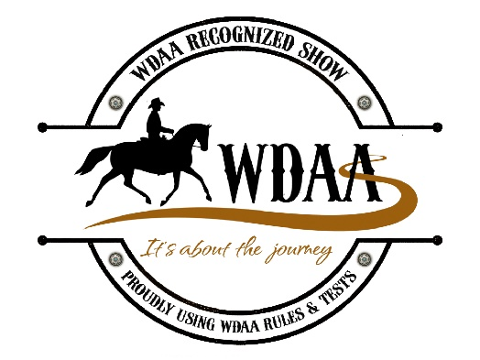
WDAMA Virtual Western Dressage Late Summer
September 6, 2020
Tests Submission August 5 thru September 1 at midnight EST
Judge: Fatima Pawlenko-Kranz – WDAA/USEF – “R”
WDAA Show Recognition Number: 20-345
Show Manager/Secretary: Isabelle Matsell
Email: info@wdama.org or Call/Text (617) 281-6761

Test Submission
· Facebook Test Submission: Go to the Western Dressage Association of America-Massachusetts Affiliate page. Go to photos/ albums and place your video in the appropriate album (every level/test has an album)
https://www.facebook.com/pg/Western-Dressage-Association-of-America-Massachusetts-Affiliate-171272730204113/photos/?ref=page_internal
· Tests may also be emailed to info@wdama.org or uploaded to YouTube with a shared link on the Facebook page
· Once the tests are submitted, they cannot be altered

Show Fees:
· $10.00 Horse/Rider Fee – Regardless of how many tests submitted
· $25.00 Per Test

Prizes:
· Ribbons 1st – 6th Place & Prizes to 1st Place
· Hard copy of WDAA Tests

General Virtual WDAA Show Rules:

· Same rules apply as if you were at regular WDAA Horse Show – USEF/WDAA Rule Governed
· Videos of tests must be unedited from start to finish. They must be one continuous recording.
· After entering the arena, prior to beginning the test a sign must be held up showing the name of the show, date of the show and horse’s name. The sign must be held in the top right corner of the frame so it will not interfere with the view of the center line for the judge. Remove the sign just before beginning the ride.
· Ridden tests may be submitted to ONLY ONE online show. A video of a test/ride from another competition that has already been judged must be eliminated. Any video suspected of having been filmed during another competition will not be scored.
· As soon as the test is finished, the camera must circle the horse and rider showing equipment and attire.
· Following equipment check, the rider will dismount and drop the bit so it can be recorded.
· The test must be videoed from C, where the judge would normally be seated.
· The test may be called. The caller is to be positioned at B or E.
· Coaching during the test is not allowed.
· The natural background sound for the test must be audible. Tests with no sound at all will not be accepted.
· Bridle or saddle pad numbers are not allowed.
· Horse/Rider combination may only enter two consecutive levels, Freestyle levels included, at a single competition. Example: Competitors may ride both Introductory and Basic level OR Basic level and Level one in one show, but they may NOT ride Introductory level and Level One tests in the same show.
· Legal attire can be as simple as jeans, western type shirt and western type boots, and a cowboy hat. An ASTM SEI approved riding helmet is also correct and does not need to be of western type. A simple western saddle and western type bridle with a simple snaffle bit are correct and legal for ALL levels of Western Dressage. A Hackamore (Bosal) is permitted on a horse of any age at any level.

Important notes:

1.Tying a horse’s tongue down in any way is prohibited and will result in elimination.
2. A saddle must be used. No bareback riding is allowed.
3. Ear nets are permitted.
4. Side reins, running reins, or martingales of any kind are NOT ALLOWED.
5. All boots or bandages are NOT ALLOWED.
6. Fly masks are NOT ALLOWED

Classes Offered

1. Western Dressage Intro Test 1 Open
2. Western Dressage Intro Test 2 Open
3. Western Dressage Intro Test 3 Open
4. Western Dressage Intro Test 4 Open
5. Western Dressage Intro Test 1 Amateur
6. Western Dressage Intro Test 2 Amateur
7. Western Dressage Intro Test 3 Amateur
8. Western Dressage Intro Test 4 Amateur
9. Western Dressage Basic Test 1 Open
10. Western Dressage Basic Test 2 Open
11. Western Dressage Basic Test 3 Open
12. Western Dressage Basic Test 4 Open
13. Western Dressage Basic Test 1 Amateur
14. Western Dressage Basic Test 2 Amateur
15. Western Dressage Basic Test 3 Amateur
16. Western Dressage Basic Test 4 Amateur
17. Western Dressage Level 1 Test 1 Open
18. Western Dressage Level 1 Test 2 Open
19. Western Dressage Level 1 Test 3 Open
20. Western Dressage Level 1 Test 4 Open
21. Western Dressage Level 1 Test 1 Amateur
22. Western Dressage Level 1 Test 2 Amateur
23. Western Dressage Level 1 Test 3 Amateur
24. Western Dressage Level 1 Test 4 Amateur
25. Western Dressage Level 2 Test 1 Open
26. Western Dressage Level 2 Test 2 Open
27. Western Dressage Level 2 Test 3 Open
28. Western Dressage Level 2 Test 4 Open
29. Western Dressage Level 2 Test 1 Amateur
30. Western Dressage Level 2 Test 2 Amateur
31. Western Dressage Level 2 Test 3 Amateur
32. Western Dressage Level 2 Test 4 Amateur
33. Western Dressage Level 3 Test 1 Open
34. Western Dressage Level 3 Test 2 Open
35. Western Dressage Level 3 Test 3 Open
36. Western Dressage Level 3 Test 4 Open
37. Western Dressage Level 3 Test 1 Amateur
38. Western Dressage Level 3 Test 2 Amateur
39. Western Dressage Level 3 Test 3 Amateur
40. Western Dressage Level 3 Test 4 Amateur
41. Western Dressage Level 4 Test 1 Open
42. Western Dressage Level 4 Test 2 Open
43. Western Dressage Level 4 Test 3 Open
44. Western Dressage Level 4 Test 4 Open
45. Western Dressage Level 4 Test 1 Amateur
46. Western Dressage Level 4 Test 2 Amateur
47. Western Dressage Level 4 Test 3 Amateur
48. Western Dressage Level 4 Test 4 Amateur
WDAMA Virtual Western Dressage Late Summer
Entry Form

Exhibitor Name: _______________________________________________
WDAA number: ____________________
Horse Name and WDAA Number: __________________________________
Address: _____________________________________________________
_____________________________________________________________

Email: ________________________________________________________

Classes Entered:

Horse/Rider Office Fee: $ 10
Tests: $25 x _____ = $
Total Enclosed: $

Payment
Paypal : info@wdama.org - Family/Friends or Cashiers Check

WDAMA
123 Crane Neck Street
West Newbury, MA 01985
617-281-676
Email: info@wdama.org

