Bridle#
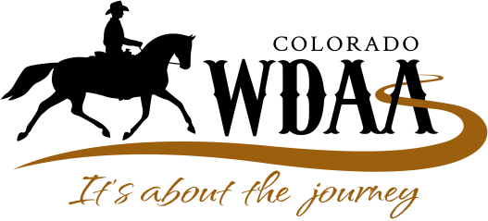
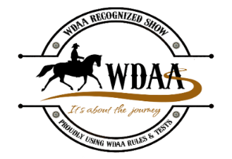
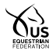USEF Lite Local Competition  Show Identification # 340522 | WDAA Horse Lifetime Points and Awards Program  Show Identification # 20-xxx

Western Dressage Association® of Colorado
Summer Sizzler Show 2020
Sunday, August 16, 2020 – Douglas County Fairgrounds, Castle Rock, CO
To register online go to Equestrian Entries (www.equestrianentries.com) by searching the calendar for the link to the WDACO Summer Sizzler Show.

OR: Complete one entry form for each horse/rider combination and show date. Type or print clearly please. Make sure to read and sign the release on the last page. Enclose all paperwork along with a check made out to WDACO and mail to: Didi DeKrey, 10318 Miners Lake Rd., Fort Collins, CO 80524.
IMPORTANT! Please provide a copy of Coggins, vaccination records, USEF waiver, and WDACO waiver with your entry.

Name of Horse | USEF Horse ID# | Breed | Sex | Color | Age

Rider Name | Birth Date (if 21 or under) | Phone
Address |  |  | Rider USEF #
Email |  |  | Rider WDAA #

Owner Name (if not rider) | Phone
Address | Owner USEF #
Email | Owner WDAA #

Trainer Name (person responsible for horse on show grounds) | Phone
Address | Trainer USEF #
Email | Trainer WDAA #

Stabling (Optional) – a separate check of $50 for stall stripping required – returned within one week after the show if stall is left clean
Arrival Date and Time
Departure Date and Time
Emergency Contact #

Class # | Division | Class Description | Fees
 |  | Classes $35 per class
 |  | Sub-total class entry fees

Fee Total
Class Entry Fees - $35 per class
Late Entry Fee (per horse/rider combination) - $30
Stall fee - $20 per day
Stall Strip fee - $50 - separate check - refundable
Trailer In fee (if not using a stall) - $10
RV site fee - $35 per day
Office fee - non-refundable | $30
USEF Drug Fees (only if USEF member requesting USEF points) $23
Level Sponsorship (circle the level) - $15 per level sponsored
Intro Basic Level 1 Level 2 Level 3 Level 4
Checks payable to WDACO $Total

THIS DOCUMENT WAIVES IMPORTANT LEGAL RIGHTS AND IT MUST BE READ CAREFULLY
BEFORE SIGNING!

WDACO RELEASE, WAIVER AND HOLD HARMLESS AGREEMENT: Every entry in a WDACO sponsored event/competition or WDACO sponsored competition shall constitute an agreement and affirmation that all participants (which include, without limitation, the owner, lessee, trainer, manager, agent, coach, driver, rider, handler and the horse), for themselves, their principles, representatives, employees and/or agents: (1) Shall be subject to the Constitution, By-Laws and rules of the WDACO, all licensing Organizations and the local rules of the competition and the rental location; (2) Represents that every horse, rider, driver, and handler is eligible as entered; (3) Agrees to be bound by the Constitution, By-Laws and rules of the WDACO, all licensing Organizations and of the competition, and will accept as final, the decision of the Hearing Committee on any question arising under said rules, and agree to hold the competition, the WDACO, other officials, directors and employees harmless for any action taken; (4) Agree that as a condition of and in consideration of acceptance of entry, they authorize the WDACO, and/or the competition management to market, transfer, assign or otherwise make any use of any photographs, likenesses, films, broadcast, cablecasts, audiotapes, or videotapes taken of the horses(s) and participants(s) while on the grounds, incident to, on in transit between the stabling facility and the event site, in any way they see fit for the promotion, cover-age or benefit of the event, sport, or the WDACO, without compensation to any of them, so long as the use neither jeopardizes amateur status nor endorses a specific product or service, and hereby expressly and irrevocably waives and releases any rights in connection with such, including any claim to invasion of privacy, right of publicity, or to misappropriation; and (5) Agree that they participate voluntarily in the competition fully aware that horse sports and all horse competitions are dangerous and involve inherent risk of serious injury or death, and by participating they expressly assume any and all risks of injury or loss, and they agree to hold the WDACO, the competition and their officials, directors, employees and agents harmless from and against all claims including claims based on negligence, breach of contract, strict liability and/or otherwise for any injury or loss suffered during or in connection with the competition, officials, directors, employees or agents of the WDACO or the competition. The construction and application of WDACO rules are governed by the laws of the State of Colorado, and any action instituted against the WDACO must be filed in the State of Colorado.

Rider Signature ___________________________________________________ Date _____________

Owner Signature _________________________________________________ Date _____________

Trainer Signature _________________________________________________ Date _____________

Parent Signature __________________________________________________ Date _____________

(if under 18 years of age)

Emergency Contact Information

Name _______________________________________ Phone ______________________________
